Analytical Paragraph:
An analytical paragraph is a type of writing that examines and interprets a specific topic or issue in detail. It involves breaking down the subject matter into its constituent parts, analyzing their significance, and offering insights or interpretations based on evidence and critical thinking. Analytical paragraphs typically include:

1. **Topic Sentence**: Introduces the main idea or argument of the paragraph.

2. **Explanation**: Provides context or background information to support the topic sentence.

3. **Evidence**: Presents evidence, examples, or data to support the analysis.

4. **Analysis**: Analyzes the evidence, explaining its significance and relevance to the main idea.

5. **Conclusion**: Summarizes the key points and may offer implications or further considerations.

Overall, analytical paragraphs aim to deepen understanding, provoke thought, and persuade readers through reasoned analysis and interpretation of the subject matter. They are commonly found in academic essays, research papers, and critical analyses across various disciplines.
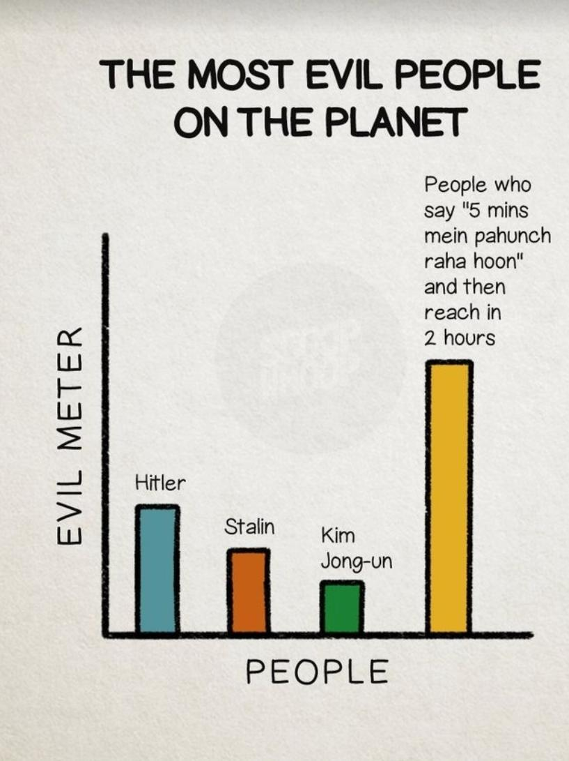

Example1: 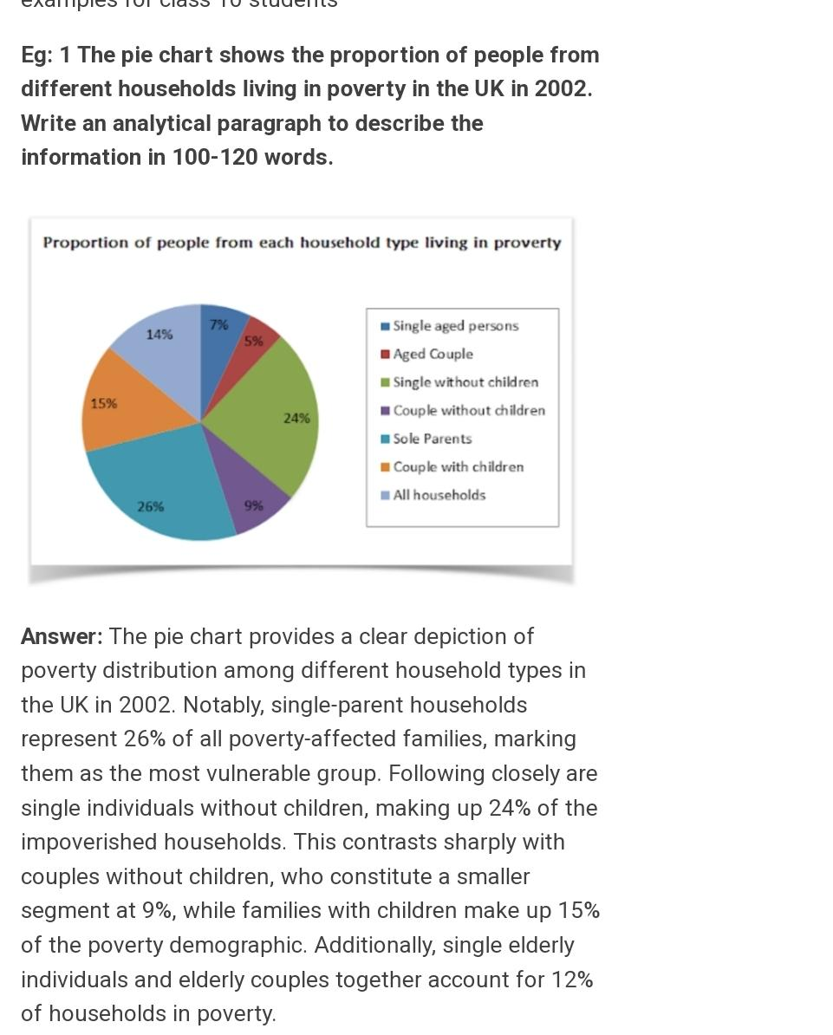

Example 2: 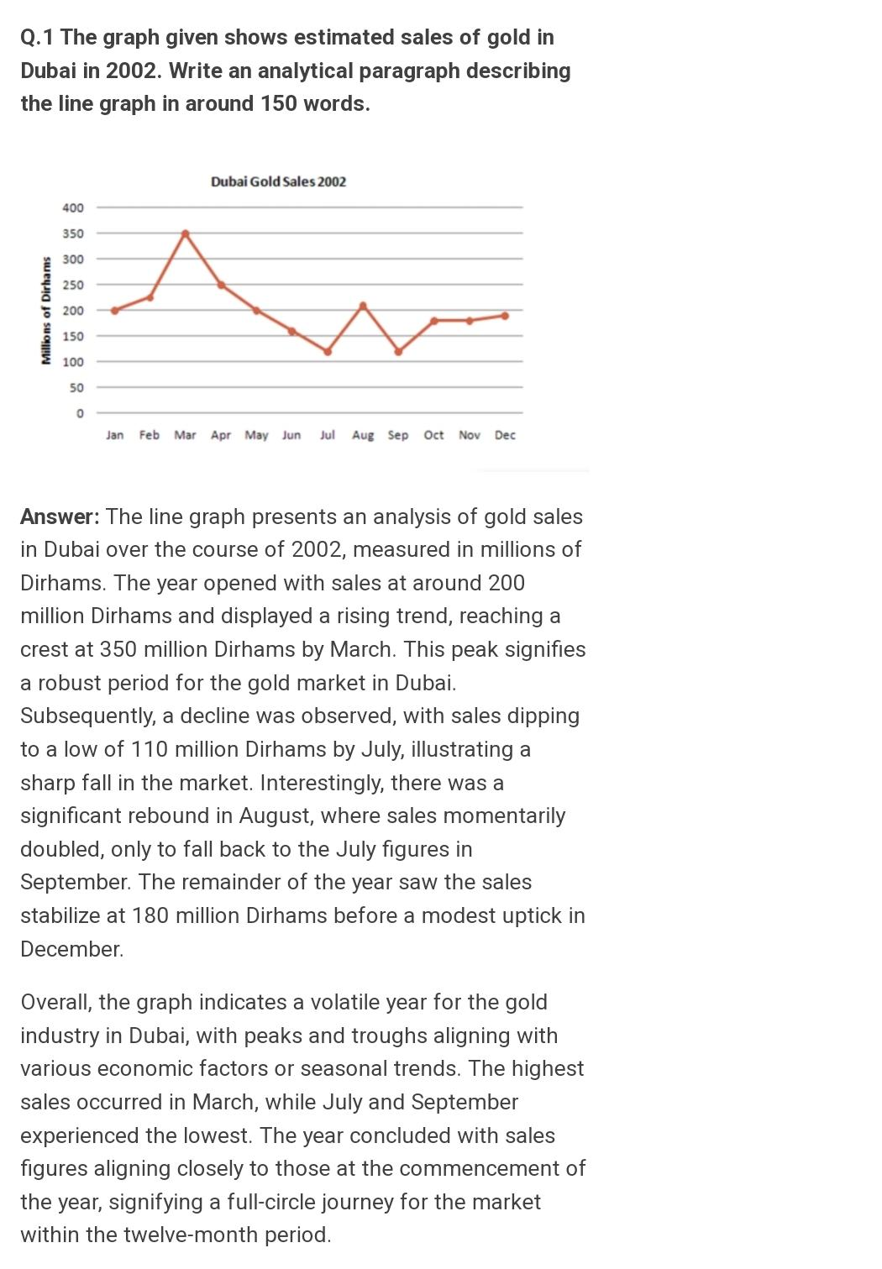

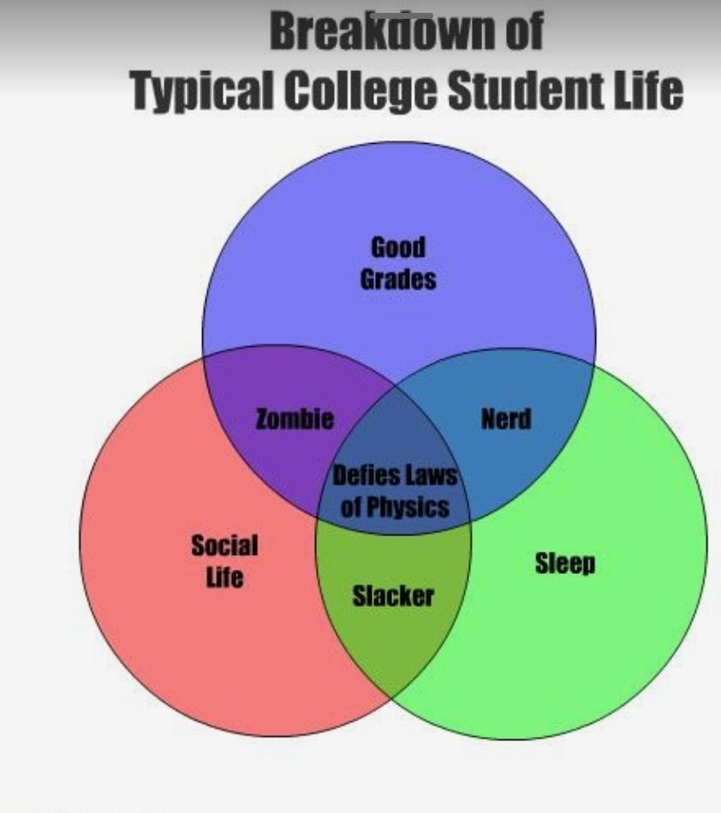

Report Writing :
Type of speech to be followed: Formal.
Report writing is the process of creating a structured document that conveys information,
analysis,
findings,
and recommendations on a specific topic or subject.
It involves organizing and presenting data, research, or observations in a clear and concise manner to inform, persuade, or guide decision-making.
Reports are commonly used in academic, business, scientific, and government settings to communicate the results of research, investigations, projects, or evaluations.
The key elements of report writing include defining the purpose and audience, conducting research or analysis, organizing information logically, and presenting it effectively through written text, visuals, and other supporting materials.

Why is report writing important?
1. **Communication**: It facilitates effective communication of information, findings, and recommendations to a specific audience, such as stakeholders, clients, or decision-makers.

2. **Documentation**: Reports serve as a formal record of research, analysis, or investigations, providing documentation of processes, results, and outcomes for future reference.

3. **Decision-making**: Reports provide decision-makers with essential information and analysis to support informed decision-making on various issues, projects, or initiatives.

4. **Problem-solving**: They help identify and analyze problems, challenges, or opportunities, offering insights and recommendations for addressing them effectively.

5. **Accountability**: Reports hold individuals, organizations, or projects accountable by documenting performance, progress, or outcomes against predefined objectives, goals, or standards.

6. **Evaluation**: They facilitate the evaluation of projects, programs, or processes by assessing their effectiveness, efficiency, and impact against established criteria or benchmarks.

7. **Planning**: Reports inform strategic planning, resource allocation, and goal-setting processes by providing data-driven insights and recommendations for future actions or initiatives.

8. **Knowledge sharing**: They contribute to knowledge sharing and dissemination within organizations, academic institutions, or professional communities, allowing for the exchange of ideas, best practices, and lessons learned.

Overall, report writing plays a crucial role in effective communication, decision-making, problem-solving, and accountability across various domains and sectors.

Important parts :
1. **Title Page**: Includes the title of the report, your name, the date, and any other pertinent information like the organization or course name.

2. **Abstract/Executive Summary**: Summarizes the main points of the report, including its purpose, methodology, key findings, and recommendations.

3. **Table of Contents**: Lists the sections and subsections of the report along with their page numbers for easy navigation.

4. **Introduction**: Introduces the topic, provides background information, states the purpose and objectives of the report, and outlines the scope and methodology.

5. **Body**: This is the main section of the report where you present your analysis, findings, and discussion. Organize this section logically, with clear headings and subheadings to guide the reader.

6. **Conclusion**: Summarizes the key findings and insights from the analysis, restates the purpose of the report, and may offer recommendations or suggestions for further action.

7. **Recommendations**: If applicable, provide specific recommendations based on the findings of the report. These should be actionable and supported by the evidence presented in the body of the report.

8. **References**: List any sources cited in the report using a consistent citation style.

9. **Appendices**: Include any additional materials such as raw data, charts, graphs, or supplementary information that supports the findings presented in the report.


Make sure to proofread your report for clarity, coherence, and correctness before finalizing it.

FORMAT:

1. **Title Page**:
- Title of the report
- Your name
- Date
- Organization or course name (if applicable)

2. **Abstract/Executive Summary**:
- Summarizes the main points of the report
- Includes purpose, methodology, key findings, and recommendations

3. **Table of Contents**:
- Lists sections and subsections with corresponding page numbers

4. **Introduction**:
- Introduces the topic
- Provides background information
- States the purpose and objectives of the report
- Outlines the scope and methodology

5. **Body**:
- Presents analysis, findings, and discussion
- Organize logically with clear headings and subheadings

6. **Conclusion**:
- Summarizes key findings and insights
- Restates the purpose of the report
- Offers recommendations or suggestions for further action

7. **Recommendations** (if applicable):
- Provides specific recommendations based on findings
- Supported by evidence from the body of the report

8. **References**:
- Lists sources cited in the report using a consistent citation style

9. **Appendices**:
- Includes additional materials such as raw data, charts, or graphs
- Supports findings presented in the report

Remember to adhere to any specific guidelines or requirements provided by your instructor, organization, or publication when formatting your report. This outline provides a general structure, but the content and sections may vary depending on the purpose and audience of your report.

Example 1:Report on a hypothetical research study about the impact of social media on teenagers' mental health:

---

**Title**: The Impact of Social Media on Teenagers' Mental Health

**Author**: John Smith

**Date**: March 18, 2024

**Abstract**:
This report examines the relationship between social media usage and teenagers' mental health. The study utilized surveys and interviews to gather data from a sample of 200 teenagers aged 13-18. Key findings indicate a correlation between excessive social media use and increased feelings of anxiety and depression among teenagers. Recommendations are provided for parents, educators, and policymakers to address these issues effectively.

**Table of Contents**:
1. Introduction
2. Methodology
3. Findings
4. Discussion
5. Conclusion
6. Recommendations
7. References
8. Appendices

**Introduction**:
Social media platforms have become ubiquitous in teenagers' lives, raising concerns about their potential impact on mental health. This report aims to investigate the relationship between social media use and teenagers' mental well-being.

**Methodology**:
- Survey design: A questionnaire was developed to assess social media usage patterns, frequency, and its perceived impact on mental health.
- Sample selection: 200 teenagers aged 13-18 were randomly selected from local schools.
- Data collection: Surveys were administered online, followed by semi-structured interviews with a subset of participants.
- Data analysis: Quantitative data were analyzed using statistical software, while qualitative responses were coded and thematically analyzed.

**Findings**:
- 75% of respondents reported spending over 3 hours per day on social media.
- 60% indicated experiencing feelings of anxiety or depression related to social media use.
- The most commonly cited stressors included cyberbullying, social comparison, and fear of missing out (FOMO).

**Discussion**:
The findings suggest a concerning trend regarding the impact of social media on teenagers' mental health. Excessive use, coupled with exposure to cyberbullying and unrealistic social comparisons, appears to contribute to feelings of anxiety and depression among adolescents.

**Conclusion**:
The study highlights the need for greater awareness and proactive measures to address the negative effects of social media on teenagers' mental well-being. Parents, educators, and policymakers must work together to promote healthier online behaviors and provide support for vulnerable individuals.

**Recommendations**:

- Implement educational programs to raise awareness of healthy social media usage and digital literacy skills.
- Encourage open communication between parents and teenagers regarding social media habits and concerns.
- Advocate for stricter regulations and policies to combat cyberbullying and harmful content on social media platforms.

**References**:
[List of cited sources]

**Appendices**:
- Survey questionnaire
- Interview transcripts
- Statistical analysis output

---
This example provides a basic structure for a report on the impact of social media on teenagers' mental health. Actual reports may vary in length, detail, and complexity depending on the specific research study and its findings.



Example 2: focusing on a market analysis for a new product launch:

---

**Title**: Market Analysis Report for XYZ Company's New Product Launch

**Author**: Emily Johnson

**Date**: March 18, 2024

**Abstract**:

This report presents a comprehensive market analysis for XYZ Company's upcoming product launch. The analysis examines market trends, consumer behavior, competitor landscape, and potential opportunities and challenges. Key findings indicate strong demand for the product category, with opportunities for XYZ Company to capitalize on emerging market trends and differentiate itself from competitors.

**Table of Contents**:

1. Introduction
2. Methodology
3. Market Overview
4. Consumer Behavior
5. Competitor Analysis
6. SWOT Analysis
7. Conclusion
8. Recommendations
9. References
10. Appendices

**Introduction**:

XYZ Company is preparing to launch a new product and seeks to understand the market landscape to inform its marketing and sales strategies. This report provides an analysis of the market conditions, consumer preferences, and competitive environment to support the successful launch of the new product.

**Methodology**:

- Secondary research: Utilized industry reports, market studies, and academic literature to gather information on market trends and consumer behavior.
- Primary research: Conducted surveys and interviews with target consumers to gain insights into their preferences, needs, and purchase behavior.
- Competitive analysis: Examined competitors' product offerings, pricing strategies, distribution channels, and marketing tactics.

**Market Overview**:

- Overview of the industry landscape, including market size, growth projections, and key drivers.
- Analysis of target market segments, demographics, and psychographics.
- Identification of emerging trends, technological advancements, and regulatory factors influencing the market.

**Consumer Behavior**:

- Insights into consumer preferences, purchase motivations, and decision-making processes.
- Analysis of product features, pricing sensitivity, brand loyalty, and purchase channels preferred by target consumers.
- Assessment of potential barriers or concerns affecting adoption of the new product.

**Competitor Analysis**:

- Profile of major competitors in the market, including their market share, strengths, and weaknesses.
- Comparison of competitors' product offerings, pricing strategies, and distribution networks.
- Evaluation of competitors' marketing messages, promotional activities, and brand positioning.

**SWOT Analysis**:

- Strengths, Weaknesses, Opportunities, and Threats analysis to assess XYZ Company's internal capabilities and external market conditions.
- Identification of strategic advantages and potential risks associated with the new product launch.

**Conclusion**:

The market analysis reveals significant opportunities for XYZ Company to introduce its new product successfully. With strong demand in the market, favorable consumer sentiment, and a competitive landscape ripe for innovation, XYZ Company is well-positioned to capture market share and drive growth.

**Recommendations**:

- Develop targeted marketing campaigns to raise awareness and generate excitement for the new product.
- Differentiate the product through unique features, value-added services, or strategic partnerships.
- Monitor market trends and consumer feedback to adapt marketing strategies and product offerings accordingly.

**References**:

[List of cited sources]

**Appendices**:

- Survey questionnaire
- Interview transcripts
- Competitive analysis matrix

---

GUYS I'M KIDDING!!!!
 CHILLAX! I ADORE Y'ALL


For your patience and undivided (LIES) attention.

